**Evidence for Project Unit**

Ewa Lipinska

Cohort E20

**P. 1 Github Contributors page**



Evidence for unit

**P. 2 Project Brief**



Evidence for unit

**P. 3 Use of Trello**

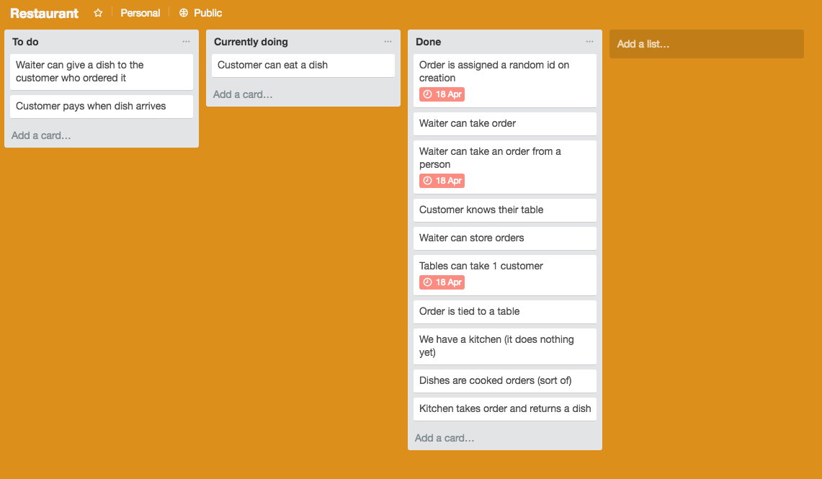

**P. 4 Acceptance Criteria**



Evidence for unit

**P. 5 User sitemap**

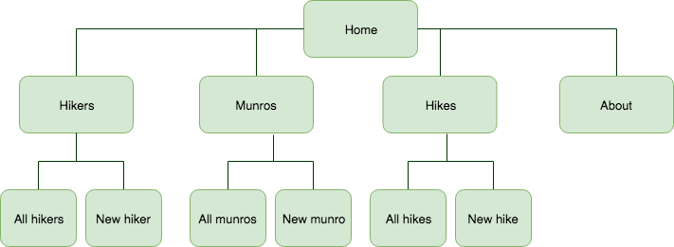

**P. 6 Wireframes designs**

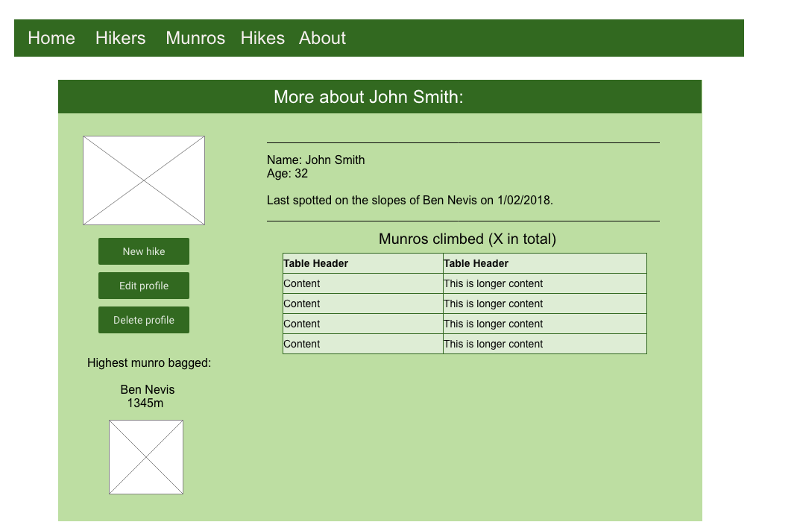

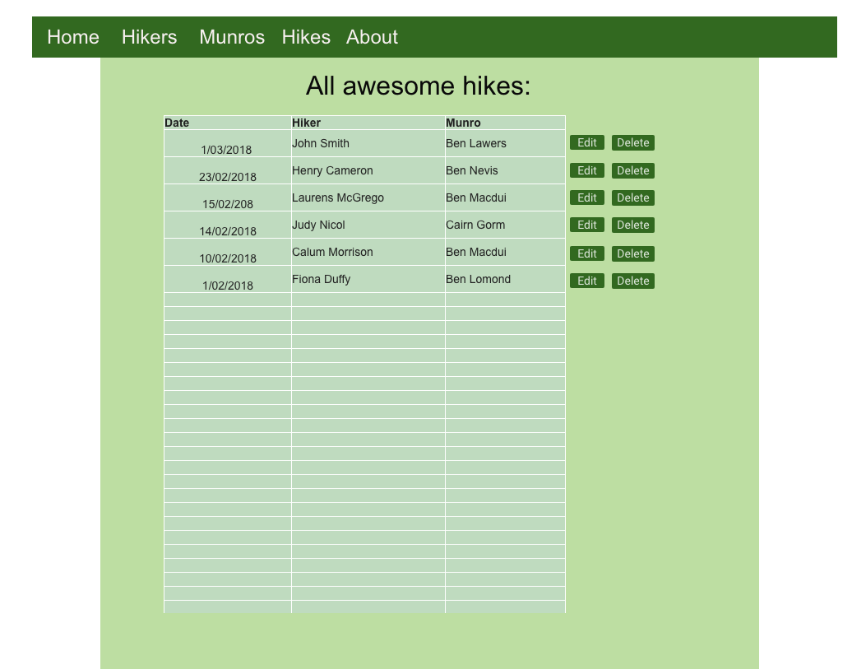

**P. 7 System interactions diagrams**

|  |  |
| --- | --- |
| Evidence for unit | Evidence for unit |

**P. 8 Two Object Diagrams**



Evidence for unit



Evidence for unit

**P. 9 Choice of two algorithms (find the algorithms on a program you might have written, show the code you have used. )**

**On this example please take a screenshot and write what it is doing and why you decided to use it.**

**P. 10 Example of Pseudocode**

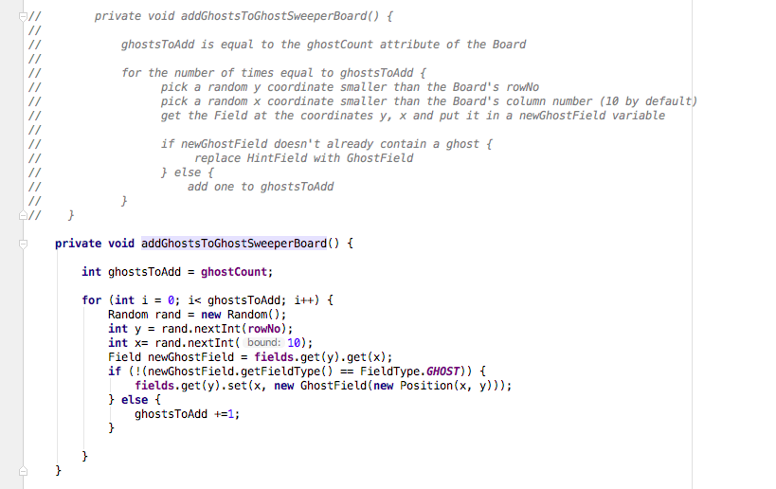

(The function aims to populate the board for a GhostSweeper game (similar to MineSweeper) with Ghosts when a new Board is created)

**P. 11 Github link to one of your projects**

<https://github.com/elipinska/codeclan_project_1_munro_bagging_app> 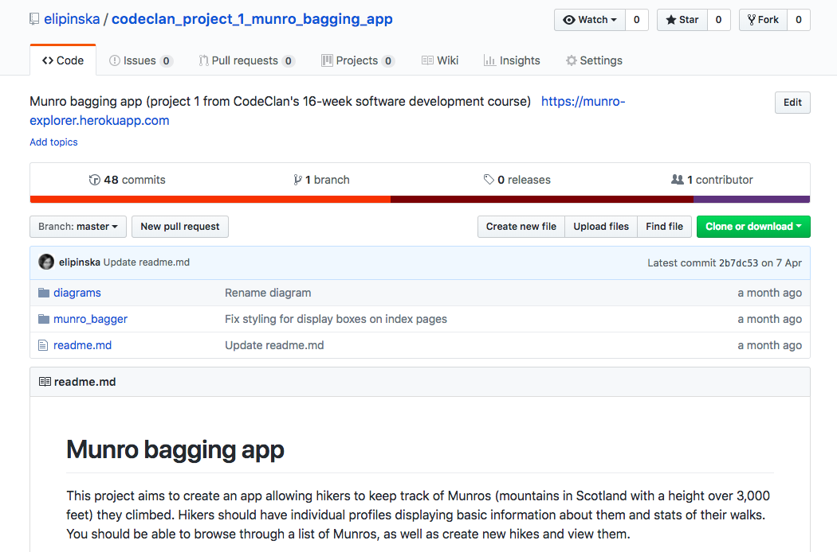

**P. 12 Screenshot of your planning and the different stages of development to show changes.**

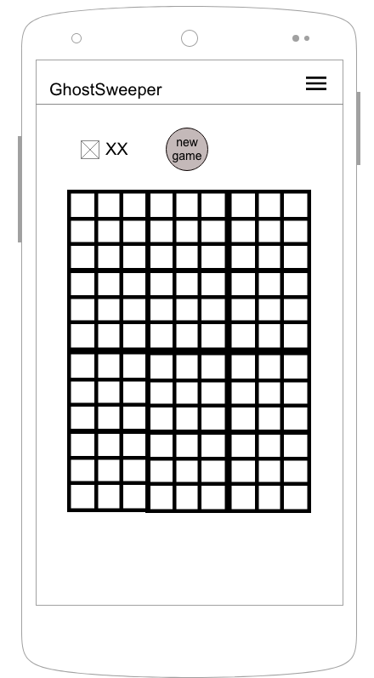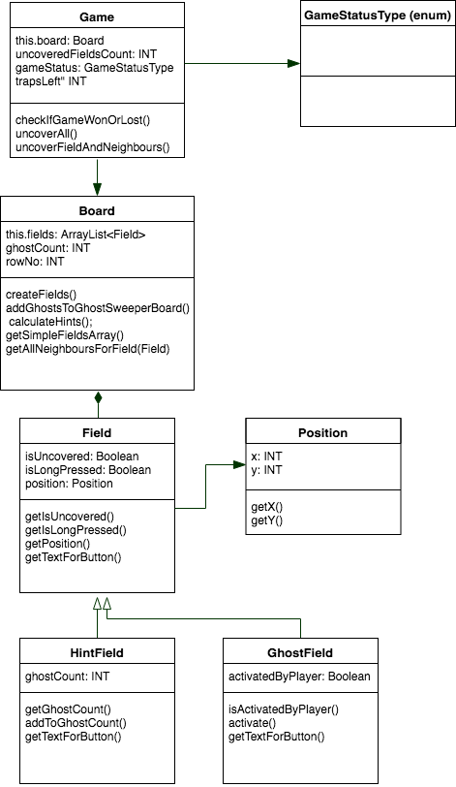

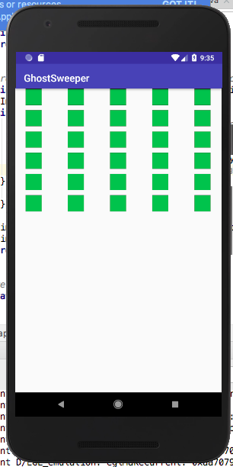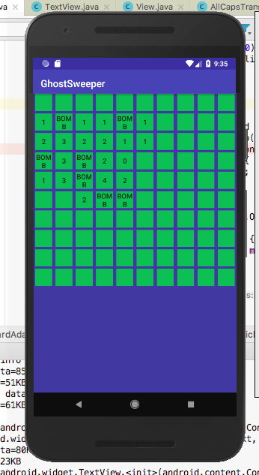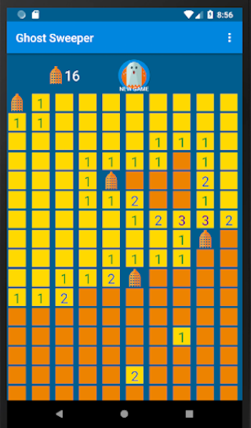

**P. 13 User input**

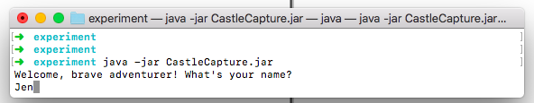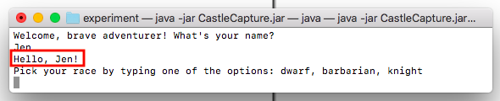

**P. 14 Interaction with data persistence**

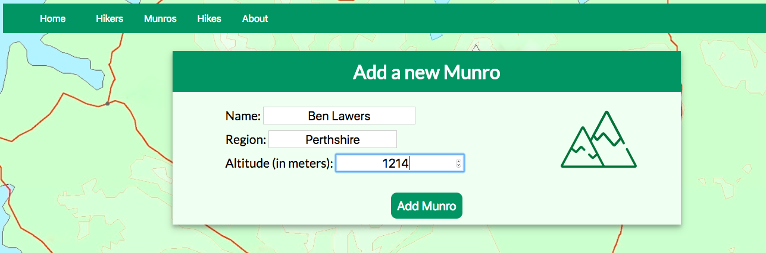

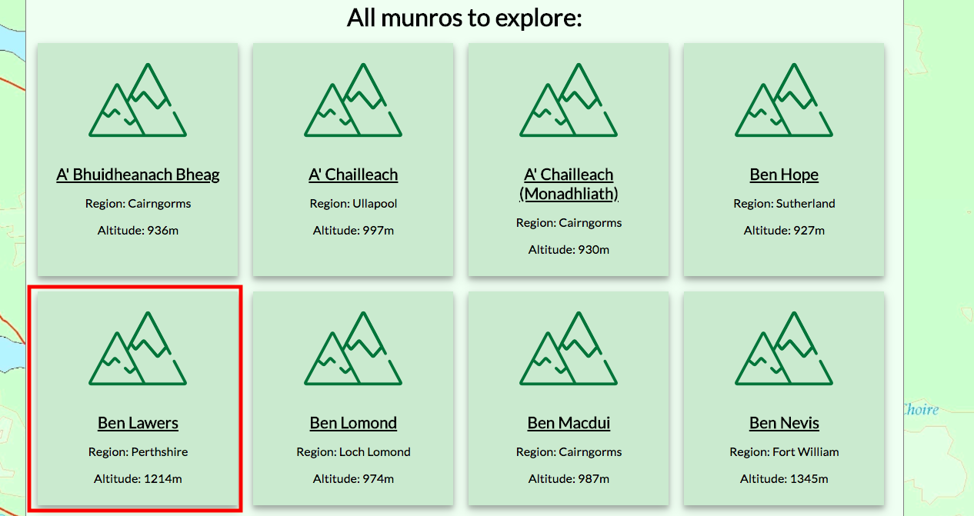

**P. 15 User output result** 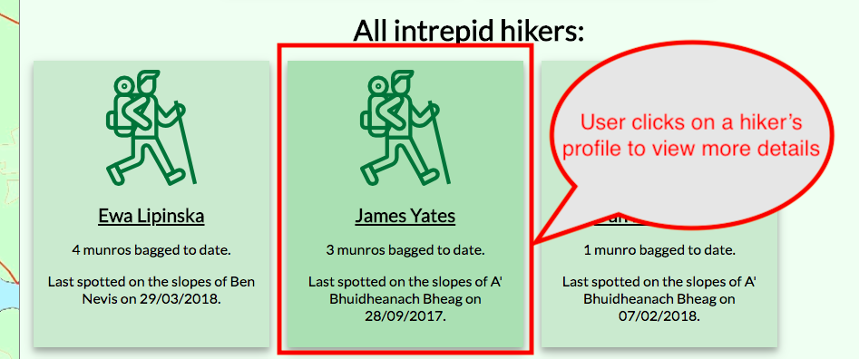

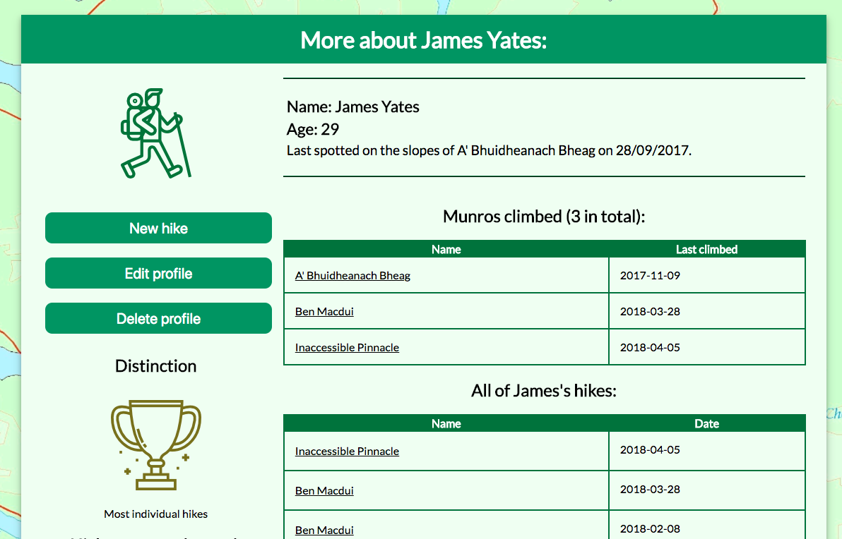

**P. 16 API being used in a program**

**Code that implements an API**

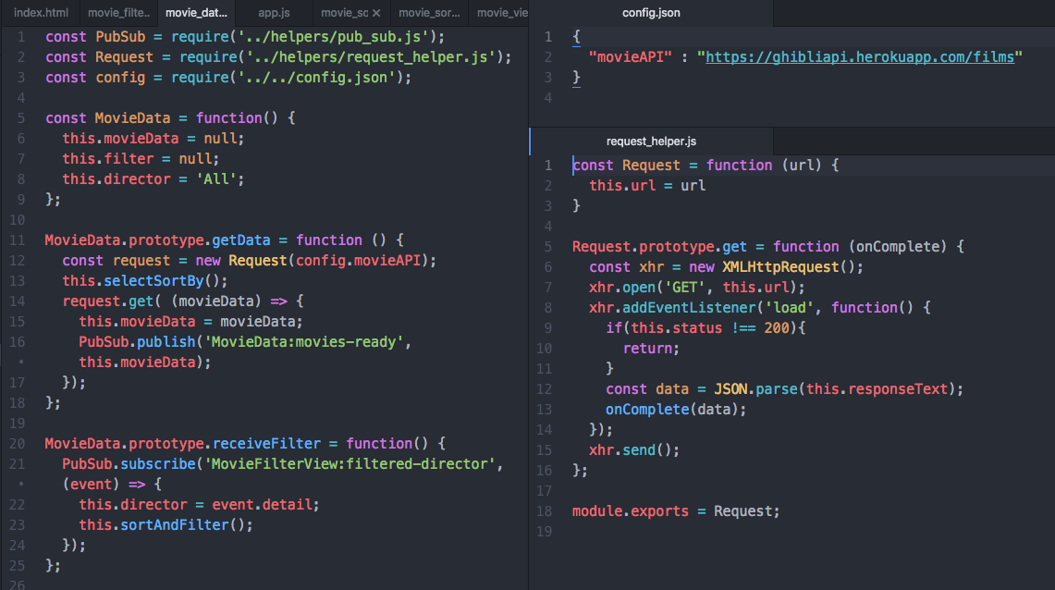

**API being used in a program whilst running**

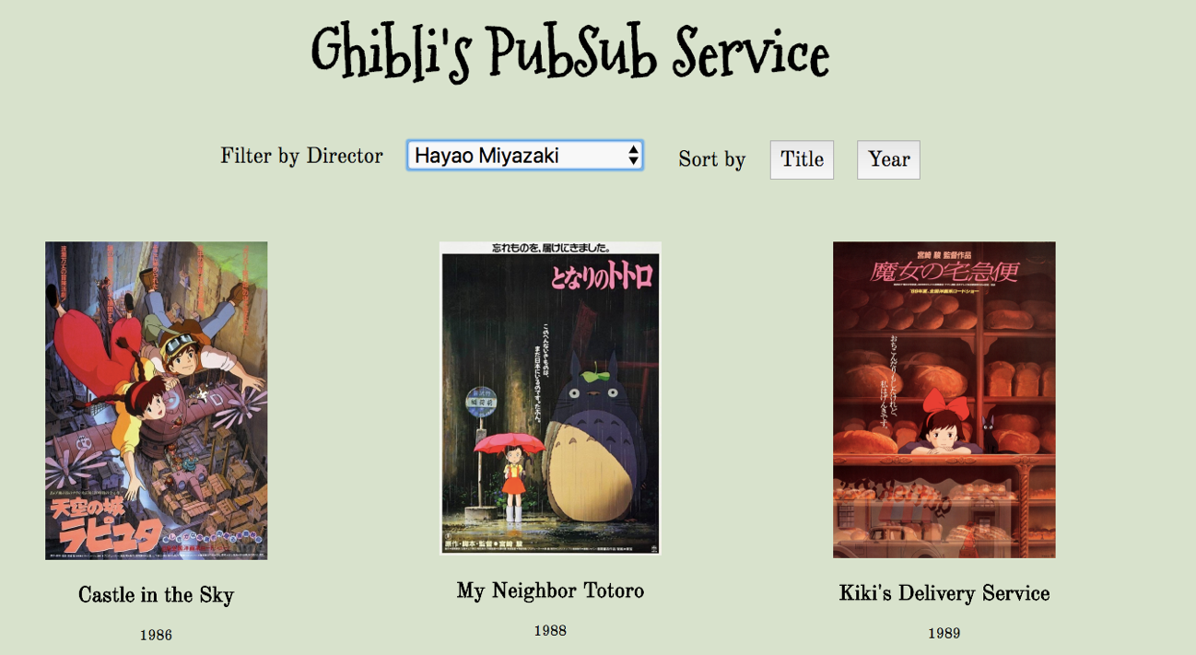

**P. 17 Bug tracking report showing the errors diagnosed and corrected.**



Evidence for unit

**P. 18 Testing your program**

